Tips to Choosing a Manuscript Typing Service Provider
Manuscripts are simply defined as the original copy of an author’s book or article before it is printed. These manuscripts are handwritten by an author before the invention of computers. Considering the importance of the manuscripts, manuscript typing services started to convert handwritten into digital formats for an easy access of content to many people across the globe. This service requires time, accuracy and concentration to perform the task for all individuals, who needs this service.
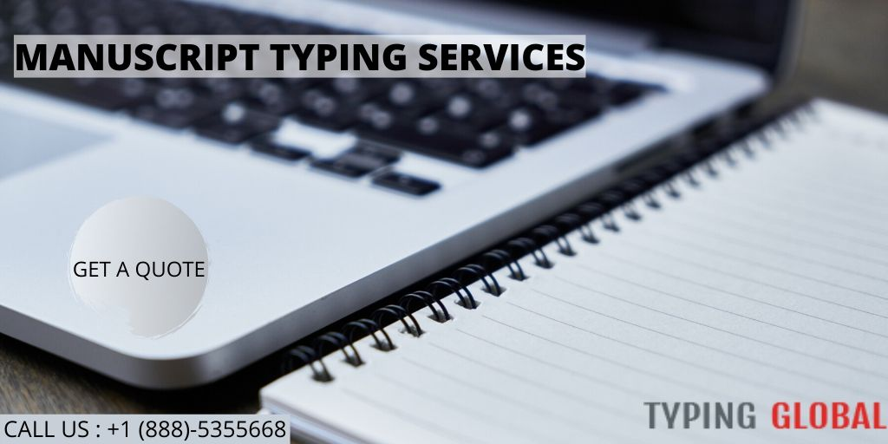
We have a team of professional who are experts in manuscript typing. They will help you deal with all your complex manuscripts that have various symbols and scripting. For example, if you search for manuscript typing services near me, it appears with a bunch of typing service companies near your location, so you should only the best service that maintains the essence of your original manuscript. Considering the customers satisfaction, our team acquired a long tenure of successful experience in this field by serving our clients all over the world in a reasonable turnaround time. Because of the skilled professionals, your manuscripts are ready to publish to everyone by eliminating every punctuation mark errors and spell errors in it.
By considering customers need, our handwritten manuscript typing services consist of certified typists, who offers multilingual support in a customized format. Adding to their requirement, we ensure timely delivery with services starting at just $2.63/page.
Steps to get our typing service:
By our three-step easy process, you can get your manuscripts typed and reach to you in a defined time.
Step 1: Fill your project details in the form given
Step 2: Depending on the size of your project, an estimated price quote displayed instantly.
Step 3: After the satisfactory of the price displayed, you can place your order and proceed with the payment.
Once after the confirmation of your order, our expertise starts working on it to provide the best service in the market in a possible timeframe.
Manuscript typing by our expertise include:
- Before proceeding with the task, our expertise analyzes the exact value, essence and content of the manuscript.
- Our typists ensure all the quality parameters by emphasizing deep efforts on it.
- Considering delivery time, our manuscript typists will not damage the required quality in the output.
- Depending on the manuscript length and subject, a team of manuscript typists engage on the task to provide the best of best service in the industry.
- Finally, the manuscript typed undergoes quality check by the experts eliminating the spelling mistakes and punctuation mark mistakes.
What are the different typing services we offer?
As mentioned above, our professionals with excellent typing speed and years of successful experience in this field, they can help our customers in providing typing services that include,
- Typing handwritten manuscripts
- Typing manuscript into MS word
- Typing a story from the manuscript, irrespective of its length.
- Typing manuals even with complex terminologies.

