Wall Art Décor That Spikes the Imagination in Extraordinary Ways
Art has always been a subjective matter. Every individual has their own preferences and they are aware of the kind of art they enjoy the most. Same goes for wall arts. While decorating the homes, several aspects including wall arts come into speculation – what kind of wall art should be used. In all honesty, there are thousands of things to be considered before choosing any wall art or an element related to interior decoration. There has to be a color palette, appropriate theme, wall paint, matching furniture and other interior decoration items. But, too often wall art is taken as a second choice; something to be referred as an afterthought as interior decoration is finished and everything is in place. Instead, wall art décor is a primary binding source of interior designing, as it becomes the focal point of any room.
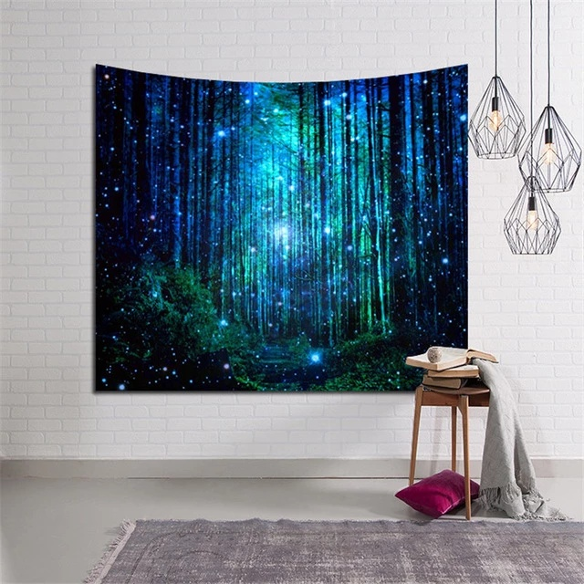
Take it this way, trying to find a wall art that matches the themes and colors of an already designed room is a bit harder than taking inspiration from an already selected wall art to decorate the designated area. Former is not impossible, but harder to achieve. While the latter has numerous possibilities with it and gives a lot of creative space to the designer for fabricating multiple decoration ideas that suits the personality of the person owning the place. The possibilities are endless. There is one loophole that allows for both the aforementioned methods to co-exist – Mandala wall art. It is a flexible design that fits all the backgrounds in the most uncomplicated way.
What is a Mandala?
Literally, mandala translates as ‘circle’ in Sanskrit. It is seen in many circular designs with enigmatic graphics but as a whole, every mandala represents the universe. They bear a long lineage from ancient Buddhist and Hindu religious significance. This symbol in a way erupts many explanations, all of which do agree that mandala represents how everything in the universe is connected. It also represents the union of universe and soul into a cosmetic diagram that acts as reminiscent to the individuals about their connection with infinity. Hindus are believed to be the first individuals to utilize the cosmic serenity of mandalas into meditation and religious prayers.
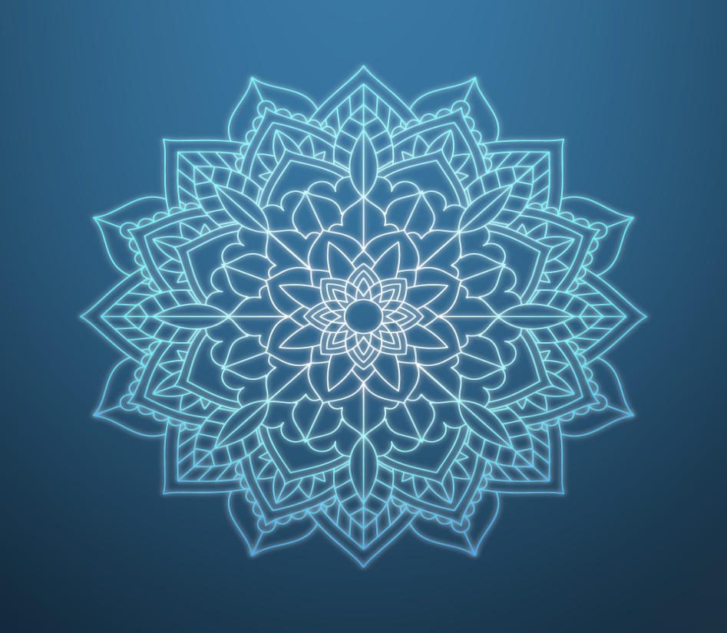
Symbolically, mandalas come in various designs but its concentric nature defines existence of unity and harmony in the world. Moreover, their positive presence is not unknown to devout mandala art appreciators. A Swiss psychiatrist, Dr. Carl Jung, states from his experience with incorporating mandalas into his clients’ treatment – by concentrating upon a mandala, the deepest human consciousness rises to a level where the true potential of self is realized by the meditator.
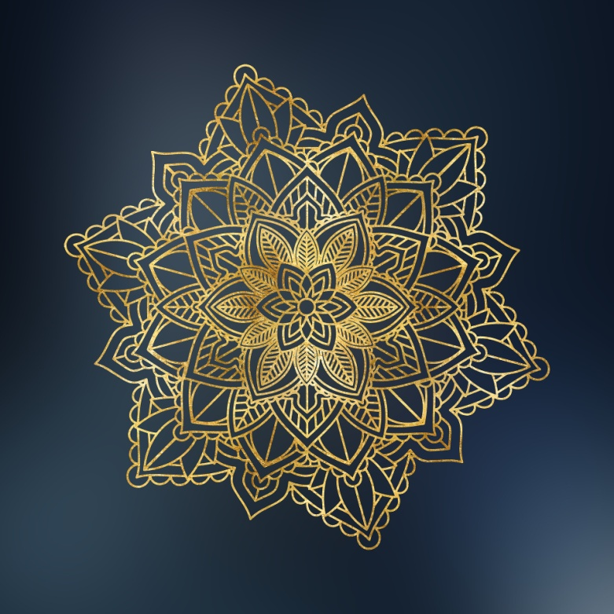
The Mandala wall art
Mandalas were always around in the Asian temples, homes, fashion and more. But they made a comeback for rest of the world through boho culture and there is no stopping. The liberating designs and colors give individuals a chance at self-expression and beautifying their homes with the help of intricate graphics and serene colors of Mandalas.
Mandala as a wall art has become an evergreen burgeon of positivity. It is so flexible in its approach that any theme would look as alluring as before with the addition of a mandala. As this design helps an individual meditate and feel a connection with cosmos, keeping it around through fashion, clothing or wall art even gives the individual a sense of oneness with self and the universe. The beauty of interior designing is that it allows any inspiring object to translate into a harmonious theme which can be incorporated while decorating a room. The ways in which a mandala wall décor can be incorporated are endless, but here are some ideas to get your creative juices running:
- The beauty of mandala is that it comes in all shades. So, if an individual wants to use a mandala wall décor in their home, it will serve the same purpose in all types of color palettes. The idea has to be that either it falls in a contrast with the chromatic vibe of room or blends in with varying shades of the same color used in the same room through multiple elements like furniture, curtains, lights, show pieces etc.
- Whatever themed room it may be, a mandala wall art will gracefully make its place in every setting. Even the most industrial or minimalistic ambiance can be enchanted with a mandala art in similar fashion. For instance, an abstract mandala wall art would work as a charm in a modern room setting. A little touch of bold colors would do wonders. The idea is to bring liveliness to any room through this enchanting design.
- Literally any room would look amazing with a mandala art added in its design. Living room, bedroom, bathroom, terrace – all the areas can be sought out with various mandala wall art designs like paintings, wall sticker, string/yarn art and the options are countless. If a room is already set up and later a need of wall art is felt, a mandala would still be the perfect choice.
- Apart from the conventional mandalas, some very interesting and modern mandala designs are emerging in the market. They still are made of concentric circle base with intricate graphics, but with more styles, like an animal or lotus shaped mandala. It brings myriad options to the table when a unique design is desired.
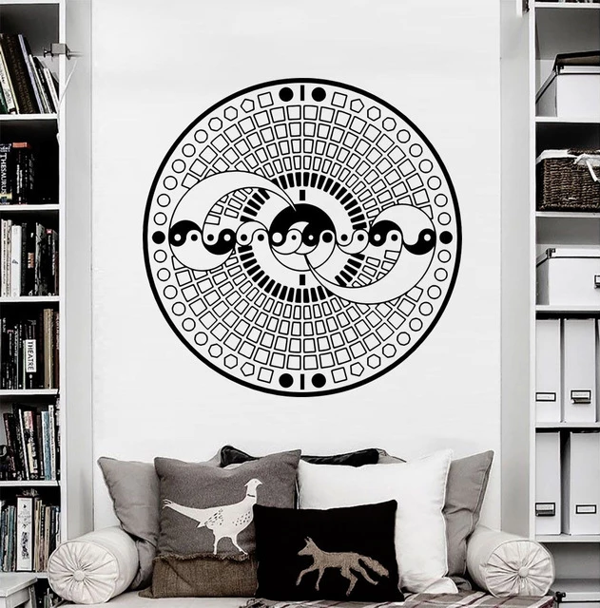
The indulgence of mandala wall arts in interior designing process is a worthwhile step. Their spiritual and psychologically compelling presence ceases the negative thoughts from entering one’s aura. This positive effect makes one highly conscious of their ability to be more spiritually content. Apart from being a marvelous décor substitute, it brings a hypnotic effect on the mind of the viewer by numbing the conclusive portion so that the creative part can run free like wild horses. Having one around for yourself on bedsheets, walls, paintings or even a decorative piece brings a sense of fulfillment to the room and your soul – while also brightening up any place’s ambience.
Author Bio:
Hello I am Alex. I'm the content crafter and businessperson. I write about the art and culture for local cities. I write for the Ashok Treasures, it’s an e-commerce platform that gives the best home decor materials. Beside this I love food and cycling.

